# JobSpark Project Management Plan

# Scope Statement

**General Description:** This project is to create an application that will match companies with prospective employees

**Deliverables:** A web application that companies and individuals can log onto to accept/reject potential employees/employers.

**Justification for the Project:** In the modern world, all other job matching applications are clunky and rely more on wording then finding good matches for companies quickly

**Constraints:** Time is a large constraint here. To build a full application we will need to build a front end and a backend. This will need to be complete with endpoints to access profile information, and match information.

**Assumptions:** Angular Materials will have the components that we will need pre-built, and a .NET REST API can publish the endpoints listed in the project charter

# Schedule

## Week 1

* Prototype of pulling a profile card and accepting/rejecting that profile card
* Backend project begins, Profile endpoints are started

## Week 2

* User screens are built and hooked up to profile endpoints
* Profile endpoints are finished

### Week 3

* Job listing endpoints are finished
* Prospective match select/update endpoints are finished
* Matching is complete on front end

## Week 4

* All endpoints complete
* Pending, match, and matched profile display is complete

Week 5

* Security testing/hardening for backend
* Polish for the front end

# Human Resources

* Backend Developer (C# .NET)
  + Cameron
* Frontend Developer (Angular 8)
  + Ryan
* Project Managers
  + Cameron
  + Ryan

# Communication Plan

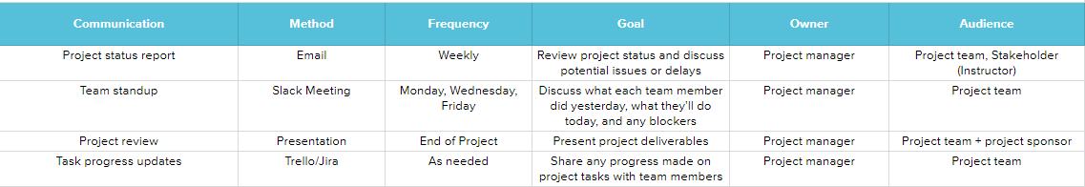

# Costs

We will need the following items for testing

|  |  |
| --- | --- |
| Item | Cost |
| Database on sql server |  |
| web hosting for application |  |

# Risks

The market is already saturated with things to help you find a job. It will be difficult to get buy in for job hunters and hiring managers after the application is complete.